Subject Area : Food Preparation and Nutrition
Year Group : 10 | Unit of Work :
Half Term : 1 | Skills:  Knowledge and understanding of:  Nutritional importance of Protein, fats, carbohydrates.  Practical Skills:  FPT1 Crudités - Knife Skills  FPT2 Stir Fry - Knife skills, Cooking methods
Reasons behind order of topic in this half term
The skill list below is the expected range for the GCSE given by AQA. The students build a portfolio of skills by cooking a wide range of products throughout the year which allow them to demonstrate numerous skills from the list below. The first 2 products are designed to ensure
everyone is working safely with a consistent message and the teacher is able to assess the student’s individual abilities as a starting point along with an underpinning of nutritional knowledge.

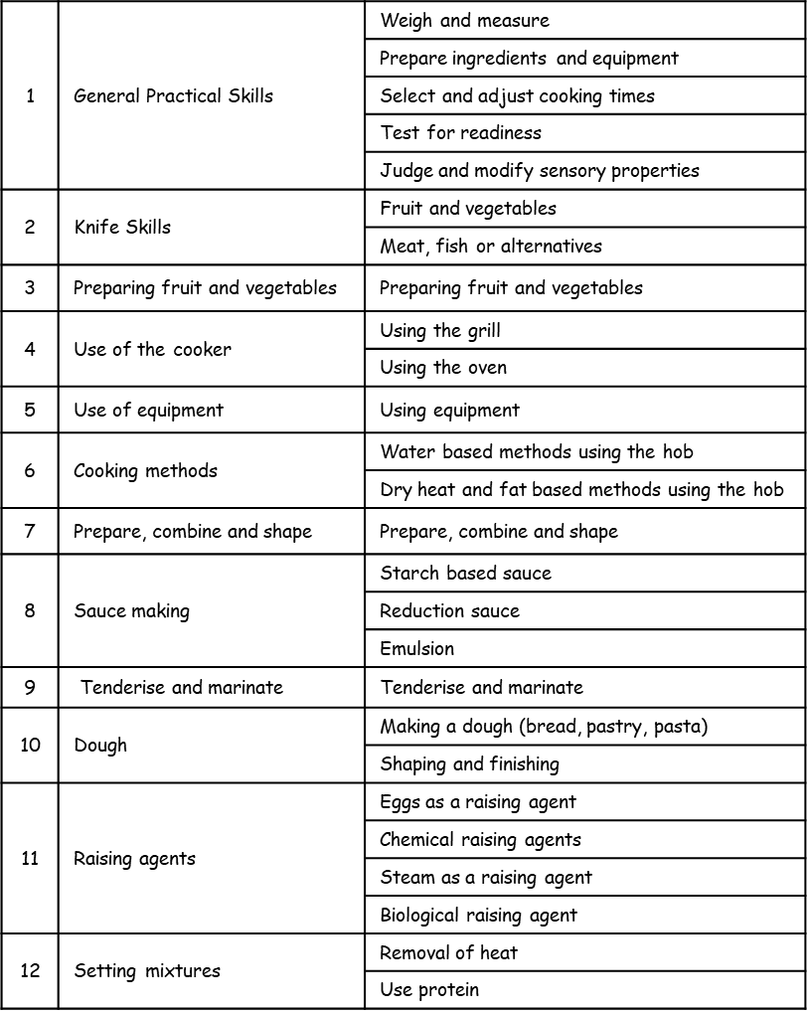

Subject Area : Food Preparation and Nutrition
Year Group : 10 | Unit of Work :
Half Term : 2 | Skills :  Knowledge and understanding of:  Nutritional importance of Vitamins, Minerals, Fibres & water  Practical Skills:  FPT3 Thai Curry – knife skills (meat/fish/alt), Sauce Making, Use of Cooker  FPT4 Choux Pastry – Pastry Making/use of equipment, sauce making, test for readiness, weighing and measuring, steam as a raising agent.
Reasons behind order of topic in this half term
The nature of this course means that the materials are best taught concurrently rather than in sections/topics. For example, practical’s need to be spaced out throughout the year and the food science for each is taught practically during the FPT sessions and will then be covered in more detail later in the year with a focus on recall of experience during practical to embed the learning. Much of the scheme is iterative, with skills being built upon session by session.

Subject Area : Food Preparation and Nutrition
Year Group : 10 | Unit of Work :
Half Term : 3 | Skills :  Knowledge and understanding of different nutritional requirements during life stages.  Applying learning to meal planning and accurate nutritional analysis.  Practical Skills:  FPT5 Puff Pastry – weighing & measuring, dough making, shaping, changing flavours, use of the oven  FPT6 Meringues – creating a foam, sauce making, presentation, testing for readiness  FPT 7 Mayonnaise – emulsion, food safety,
Reasons behind order of topic in this half term
Practical sessions are building in complexity with further skills being added. This allows students the opportunity to practice earlier skills again whilst adding new skills in. This is intended to developed independent working & confidence. Students should be building a portfolio of skills.

Subject Area : Food Preparation and Nutrition
Year Group : 10 | Unit of Work :
Half Term : 4 | Skills :  Scientific principles of properties of Protein, carbohydrates and Fat including gelatinisation, plasticity, emulsification, shortening, dextrinisation, denaturation.  Practical Skills:  FPT7 Panna cotta – using gelatine to set, presentation, sauce making, independent working, writing a time plan  FPT8 Lasagne – reduction sauce & roux/blended sauce, food safety, knife skills, use of hob, sauce making, gelatinisation, layering, use of oven, following a time plan.
Reasons behind order of topic in this half term
Students are now developing ability to alter recipes themselves, write their own time plan for practical’s lessons and concede the importance of presentation of their products. These are all skills they will demonstrate in their year 11 project and in their 3-hour practical exam.

Subject Area : Food Preparation and Nutrition
Year Group : 10 | Unit of Work :
Half Term : 5 | Skills :  Develop knowledge and understanding of food safety principles including the 4 c’s cooking, chilling, cooing and cross contamination.  Exploring the difference between beneficial and detrimental bacteria relating to food processing and food poisoning.  Practical Skills:  FPT9 Chicken Thighs – safe handling of high risk food, skinning/Boning chicken, changing flavours with herbs, testing for readiness.  FPT10 Chicken Tikka – denaturing/marinating protein
Reasons behind order of topic in this half term
The food safety aspects are taught during the time the students are working with high risk foods. They are expected to demonstrate the knowledge they have learned during theory in their practical sessions.

Subject Area : Food Preparation and Nutrition
Year Group : 10 | Unit of Work :
Half Term : 6 | Skills :  Demonstrating understanding of food choices such as vegetarian and vegan. Also, covering religious and cultural reasons behind food choices.  Knowledge of allergies and intolerance covering coeliac & lactose intolerance.  Practical Skills:  FPT11 Own choice – demonstrating skills from the range above  FPT12 Own choice - demonstrating different skills from the range above
Reasons behind order of topic in this half term
This half term prepares the students for the expectation of adapting and developing recipes in their coursework to suit a particular brief which may be a life stage, cultural influence or a diet related food aspect. The students have to show their knowledge and understanding of a particular aspect and be able to develop and make food according. This is a key aspect of their year 11 coursework; preparing them for the expectations of Year 11.

