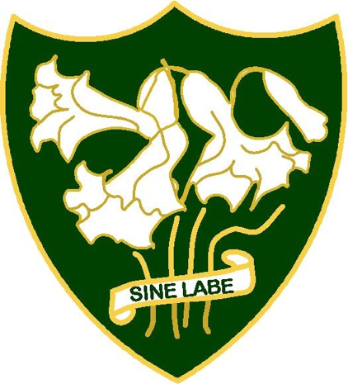

St. Anthony’s
Girls’ Catholic Academy

Information
2018-2019

Web-site: www.st-anthonys-academy.com (main school)
Web-site: Please follow the link on St. Anthony’s and St. Aidan’s main school websites for information about post-16 provision.
e-mail: enquiries@st-anthonys-academy.com (main school and sixth form)
Twitter: @St_Anthonys3 (main school)
Twitter: @AAASixthForm (sixth form)
Twitter: @BeaconSch (teaching school)
Telephone: 0191 5658904

CONTENTS

- Introduction

- History and ethos

- Location and site

- Inspection/Reports/Awards 2000-2018

- Behaviour and Attendance

- Curriculum and examinations

- Extended/extra-curricular activities

- Partnership working

1.Introduction

St. Anthony’s is an 11-18 Roman Catholic academy for girls serving the community within the City of Sunderland. There are c. 1300 pupils in the school with a buoyant sixth form of c. 400 pupils. There are c.97 teaching staff (full time and part time) and c. 50 support and administration staff (some full time and many part time). The academy works closely with St. Aidan’s Catholic Academy and shares post-16 provision as apart of St. Anthony’s and St. Aidan’s Catholic Sixth Form which delivers 35 Advanced level courses.

The majority of the students and staff are from the Roman Catholic faith tradition, given the ethos of the school. However, applications are also invited from girls of other faiths and none. The wide catchment area, which covers the whole of the City of Sunderland, provides a genuinely comprehensive intake. Pupils attending the school come from very varied backgrounds. Many parents in neighbouring authorities seek to have their daughters educated at the academy due to its inclusive nature.

OUTSTANDING
IN
ALL THREE DIOCESAN CATEGORIES 2018

- Curriculum RE
- Catholic Life of the School
- Collective Worship
OUTSTANDING
IN
ALL FOUR OFSTED CATEGORIES 2013

- Achievement
- Teaching and Learning
- Behaviour and Safety
- Leadership and Management

2. History and ethos
The school was founded by the Sisters of Mercy during the 19th century and has a fundamental commitment to high quality education for girls. The academy is supported in its work by a Chaplain. The Chaplaincy Office is situated adjacent to the School Chapel which is often the venue for retreat days, opportunities for reflection and many smaller scale liturgical activities. In 2004 the school celebrated its centenary as a secondary school with sixth form. The school has over one hundred years experience as a high quality provider of Sixth Form education for girls.
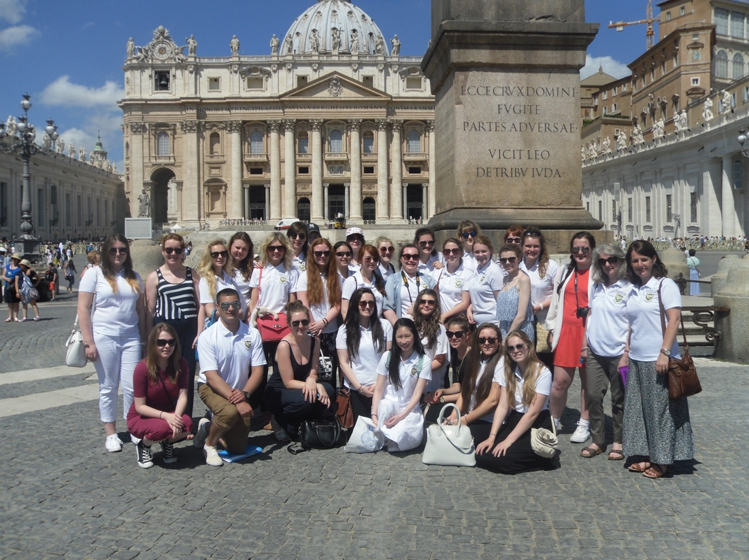

Rome Pilgrimage

3. Location, site and facilities
The school is situated in the centre of Sunderland within walking distance of train, metro and bus stations. The buildings are either brand new or refurbishd historic buildings and it is situated within a garden site within a conservation area.

All academy buildings have either been rebuilt or refurbished during the last six years with over £20m being spent in capital investment during this period.

2018
- New outdoor dining space

2017
- Refurbishment of Somerleyton House
- New Drama Studio
- Landscaping and grounds around Somerleyton House due for completion
- New student lockers

2016
- New Chapel
- New Chaplaincy Room
- New four court Sports Hall
- New Dance Studio
- New Changing Rooms
- New Multi-games area
- Four new ICT facilities
- Refurbished Student Support Area, “The Cottage”
- New Medical Room
- New admin. areas
- Access, security and car parking arranged to make best use of the site footprint

2015
- New Hall
- Major investment in a new stage lighting and sound sytem
- New Library/Learning Resource Centre
- Thirty new classrooms with new furniture and new storage facilities
- Interactive touch screen technology in tall new and refurbished teaching areas
- New Administrative areas
- New Catering Kitchen
- New Dining Room
- Twelve new Science laboratories and associated prep. rooms
- Ten new Art, Technology/ICT specialist rooms
- New student and staff washrroms/toilet facilities

2012
- The Educare Centre – an immersive environment using edge-blending technology
- Eight new classrooms

2010
- Three new Music/Performance rooms
- Three new classrooms
- Wi-fi across all the new site

4. Key Inspection/Reports/Awards 2008-2018

2018
• OfSTED Section 48 (Diocesan Inspection) – Outstanding in all three categories
•. The St. Anthony’s Team reached the “Race to the Line“ National Final
• Basic Skills quality mark for the third time
• Lord Glaramara Award – a regional award for sixth form students for the fourth time.

2017
• CIAG (Careers Information Advice and Guidance) Silver Award
• Duke of Edinburgh Award Scheme accredited centre
• Top 5% of all state schools for the English Baccalaureate 2016
• Basic skills quality mark for the second time
2016
• Top 5% of all state schools for the English Baccalaureate 2015
• Awarded the Basic Skills quality mark for Literacy and Numeracy provision for the first time.
2015
• 12 SLE’s (Specialist leaders of Education) and 1 NLE (National Leader of Education) with NCTL (The National College for Teaching and Learning).
2014
• National Teaching School Status
• National Support School
• Expert Centre for Global Learning (SSAT)
• 8 SLE’s and 1 NLE with NCTL
2013
• The Sunday Times Top 250 State Schools 2013.
• 6th of only 11 schools named in the NE in The Sunday Times top 250.
• 199th for the sixth form and 236th for the main school nationally.
• Outstanding in all three OfSTED (Section 5) categories:
- Achievement
- The quality of teaching
- Behaviour and safety
- Leadership and management
• Outstanding for overall effectiveness
Outstanding in all three Diocesan (Section 48):
- The Catholic Life of the School
- Collective Worship
- Religious Education
• Outstanding for overall effectiveness
2012
• Teacher Learner Academy status – recognised as a verifier for teacher training projects within the school and partner schools.
2011
• The school joined the Leading Edge community following the achievement of High performing Specialist School status.
• Mr. Darren Cowell was Highly Commended in the Caterer of the Year Award (National Association of School Business Managers)
2010
• Recognised as a Teacher Learner Academy by the GTC (General Teaching Council).
• Recognised as a centre for Newcastle University M.Ed. modules.
• Awarded the Basic Skills quality mark for Literacy and Numeracy provision for the first time.
• The School Food Trust School of the Month.

2009
• Awarded a second Language Specialism by the SSAT (Specialist School and Academies Trust) The only school in the city to have two specialisms.
• Awarded High Performing Specialist School status by the SSAT Recognised as a • • Teaching and Learning Academy by the G.T.C. (General Teaching Council.
• Awarded Outstanding by OfSTED for the SCITT (School Centred Initial Teacher • Training programme run in conjunction with Northumbria University.
2008
• The Financial Times Top 1,000 schools list.
• The school acquired Healthy School status.
• Awarded the Sunderland young people’s anti-bullying charter mark.
2007
The 2007 OfSTED Report remarked,
• “The school’s sixth form provision for personal development and well-being, and the care, guidance and support provided for the students are outstanding”.
The 2007 OfSTED Section 48 RE Report remarked,
• “St. Anthony’s is an outstanding Catholic girls’ school”.
• The school became aTraining School for the License to Cook Project.

5. Behaviour and attendance
Expectations with regard to pupil behaviour are high and the pastoral care of pupils is a strength. In the 2013 OfSTED rated behaviour as Outstanding and the 2007 OfSTED stated the behaviour of students was decribed as “Exemplary”. Attendance is routinely c.95% and punctuality is excellent and highly valued.

6. Curriculum,examinations and entrance into the world of work or higher education

The school sets high academic standards and has a strong commitment to the delivery of a broad and balanced curriculum. Over twenty subjects are offered at GCSE and thirty five at Advanced level.

Routinely a small number of the most able students are offered Oxbridge places and between a quarter and a third of students in the last three years have obtained places at either either Russell Group or the most prestigious Scottish Universities requiring straight A grades and a large number of A*/A grades at A level.

Retention rates are usually c.90% and entry to Higher Education has been between 80-90% during the last decade.

7. Extended/extra-curricular activities
Pupils also enjoy a wide range of extra-curricular activities. There are over one hundred and fifty groups and individual meetings each week ranging from Ski Club with an attendance of up to eighty to small one to one groups preparing for examinations. Many girls and teams perform in sports at national and international level. There are very high participation rates in sporting and other extended curricular activities.

Hundreds of educational visits have taken place during the last three years ranging from voluntary work in Cambodia and Duke of Edinburgh Award Scheme to local and national History visits.

An summer school programme, specialising in Technology, for students transferring from Y6 takes place during the first week of the summer holidays each year. There is also an Extended Schools programme for primary children which includesclasses and link visits..

Pupils are encouraged to be active citizens and take part in local events, charitable fund raising and volunteering as well as competing in local and national competitions.

The thriving Music department has undertaken Music tours Prague (2007), Dublin (2008), Cracow (2009), Rome (2010), Paris (2011), Oxford, Blenheim, Highclere and Magdalen College (2012), Venice and Verona (2013), Salzburg (2014) and Paris (2015) and London (2016) and Amsterdam (2018). The department has presented highly successful productions of, “Joseph”(2013) “Oliver” (2014) ,“Into the Woods” (2015), “Calamity Jane” (2016) and “The Sound of Music” (2018).

8. Partnership working to enhance opportunities for girls and staff
- The school is an Expert Centre for Global Learning.
- The school is a member of the Leading Edge community.
- The school is a member of the Diocesan Secondary HT’s Partnership.
- The school is involved in a Diocesan tarining for school leaders.
- The school is a member of Monkwearmouth Catholic Partnership.
- The school is also a member of the Sunderland Education Partnership, LA networking groups at all levels and Schools North East.
- The school has many international partnerships.

a)City wide partnership:

i)Monkwearmouth Catholic Partnership:
2 secondary schools:
- St. Aidan’s - Ashbrooke
- St. Anthony’s - Thornhill
9 primary schools:
- St. Mary’s - Meadowside
- St. Joseph’s - Millfield
- St. Leonard’s - Silksworth
- St. Patrick’s - Ryhope
- St. Cuthbert’s - Grindon
- St. Anne’s - Pennywell
- St. Benet’s - Fulwell
- English Martyrs - Red House
- St. John Bosco - Town End Farm

ii) City of Sunderland Secondary Headteachers and other local authority and Together for Children forums, meetings etc.
b) Regional partnership:

- Beacon Teaching School Alliance (based at St. Anthony’s) working with ANT’s (Association of North East Teaching Schools):
St. Anthony’s was awarded Teaching School status from September 2014. This involves the academy in leading Beacon Teaching School Alliance. We are part of a network of North East Teaching schools who provide:
- Initial Teacher Training
- Continuing Professional Development
- School to School Support
- Research and Development

- Roman Catholic Diocese of Hexham and Newcastle:
Diocese of Hexham and Newcastle web site: www.rcdhn.org.uk
Education Service Diocese of Hexham and Newcastle; www.edursdhn.org.uk
Diocesan Director of Education: Mrs. Deborah Fox
Diocesan Deputy Director of Education: Mrs. Lucie Stephenson

- Diocesan Emmaus Youth Village/Diocesan YMT (Youth Ministry Team):
www.ymt.org

- Schools North East:
info@schoolsnortheast.com
A forum for schools of all types across the North East of England.

c) National partnerships:

- CATSC (Catholic Association of Teachers, Schools and Colleges) : www.catsc.org.uk
- CESEW (Catholic Education Service England and Wales): www.cesew.org.uk
- • Links via the Diocesan YMT (Youth Ministry Team) to CYMFED (Catholic Youth Ministry Federation): www.cymfed.org.uk
- Association of Maintained Girls’ Schools
- SSAT (Specialist Schools and Academies Trust): www.ssat.org.uk
- Leading Edge (A Specialist Schools and Academies Trust) Partnership programme: www.ssat.org.uk

d) International partnership:

• Sweden (2003 - present) University of Linnaeus ITT - English Language, training ITT students, lecturing at Vaxjo and Kalmar
• Swaziland (2007 - present) Manzini Youth Care - Child centred practice, literacy, PHSE, charitable fundraising and project delivery
• India (2010 - present) British Council funded project KVKV School Rajkot and Panschil School Rajkot - education, annual staff and student exchanges
• China (2011- present) – languages, Mandarin Club, Confucius classroom development, Daquin Language School Exchange and No.69 Middle School Harbin.
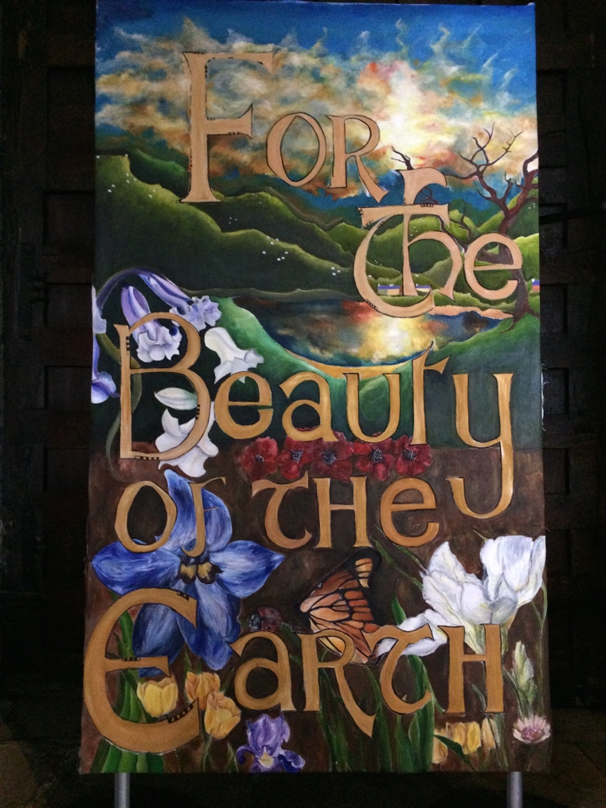

Interested in joining our community?

- Student Admissions Enquiries Y7-Y11 – contact Mrs. C. Donkin or Mrs. J. Donaldson Tel: 0191 5658904.

- Student Admissions Enquiries Y12-Y13 – contact Mrs. A. Wilkinson or Mrs. J. Haley Tel: 0191 5658904.

- Staff Vacancies – see the academy website.

- Teacher Training – see the Beacon Teaching Alliance section of St. Anthony’s website.

