May 2016

Dear Parent/Carer

Summer Term Events/Key Dates 2016

Year 11 – Governors’ Presentation
Wednesday 29th June Y11 and their invited guests 2.00 p.m. at the Stadium of Light
In order to allow Y11, their parents, staff and governors to attend Y7-10 and Y12 will be dismissed at 1.25 p.m. Girls who are unable to leave at 1.25 p.m. may work in the Library/LRC.

Year 13 – Governors’ Presentation
Monday 27th June. Y13 and their invited guests 7.00 p.m. in Our Lady’s Hall.

End of Summer Term
Pupils will be dismissed at 1.25 p.m. on Thursday 21st July to allow pupils, staff and governors to attend a Leavers’ Mass.

Summer School Programme
This involves pupils in Y6 feeder schools and those from St. Anthony’s who have signed up for the programme. It is an extensive series of classes during the first week of the summer holidays.

P.T.O.

Results Day and Registration Day
A level and AS level results day – Thursday 18th August
GCSE results day – Thursday 25th August
Y12 Registration Day – Thursday 25th August

Start of new term
Monday 5th September – Staff Training Day
Tuesday 6th September – Y7- Y12 return to school
Tuesday 6th September – Y7 and Y12 Induction Day
Wednesday 7th September – Y13 return to school

Please follow us on Twitter: @st_anthonys3
and via our website: www.st-anthonys-academy.com

Thank you for all your support this term and very best wishes for a happy and safe summer break.

Yours sincerely
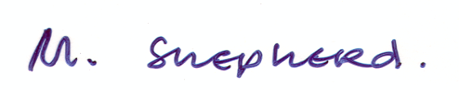
Mrs M. Shepherd
Head Teacher

